# **43A H-Bridge Drive PWM For Arduino Semiconductor BTS7960B**

**Semiconductor BTS7960B Stepper Motor Driver 43A H-Bridge**

**Drive PWM For Arduino**

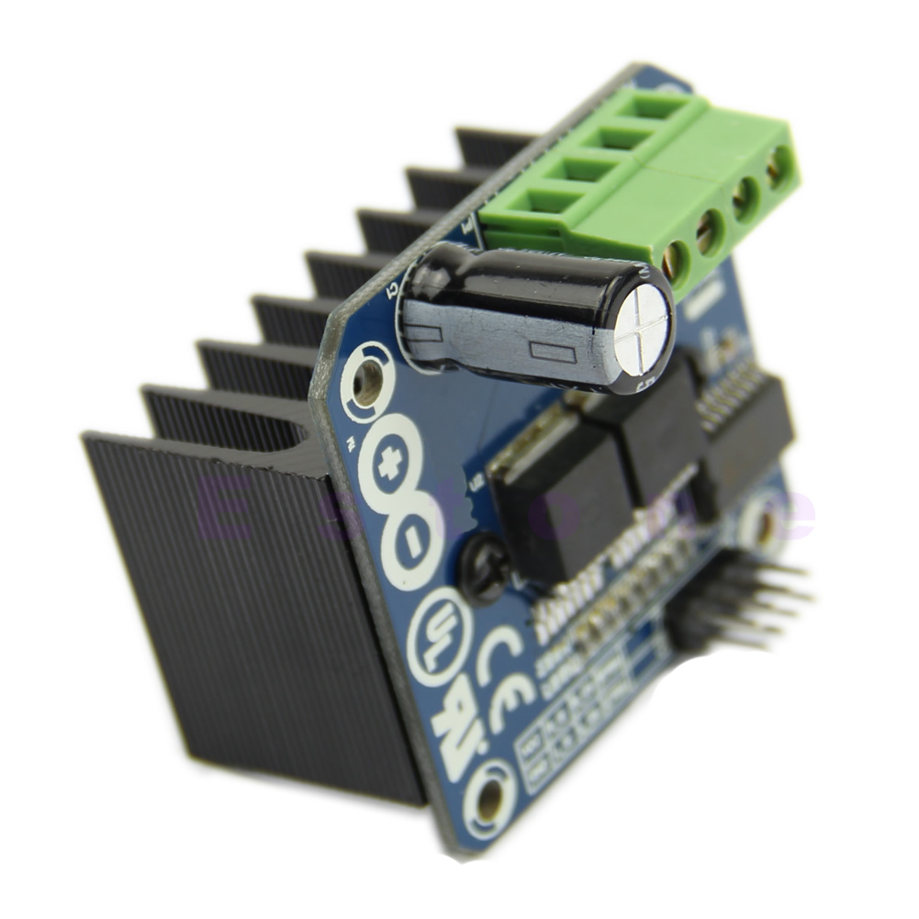

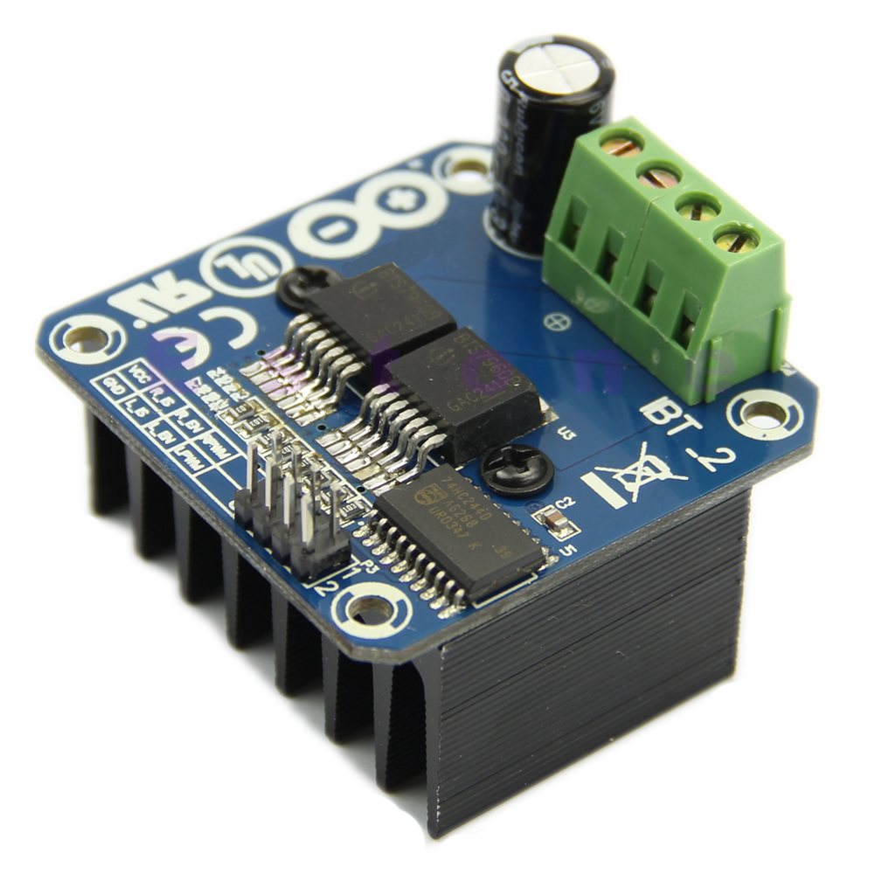 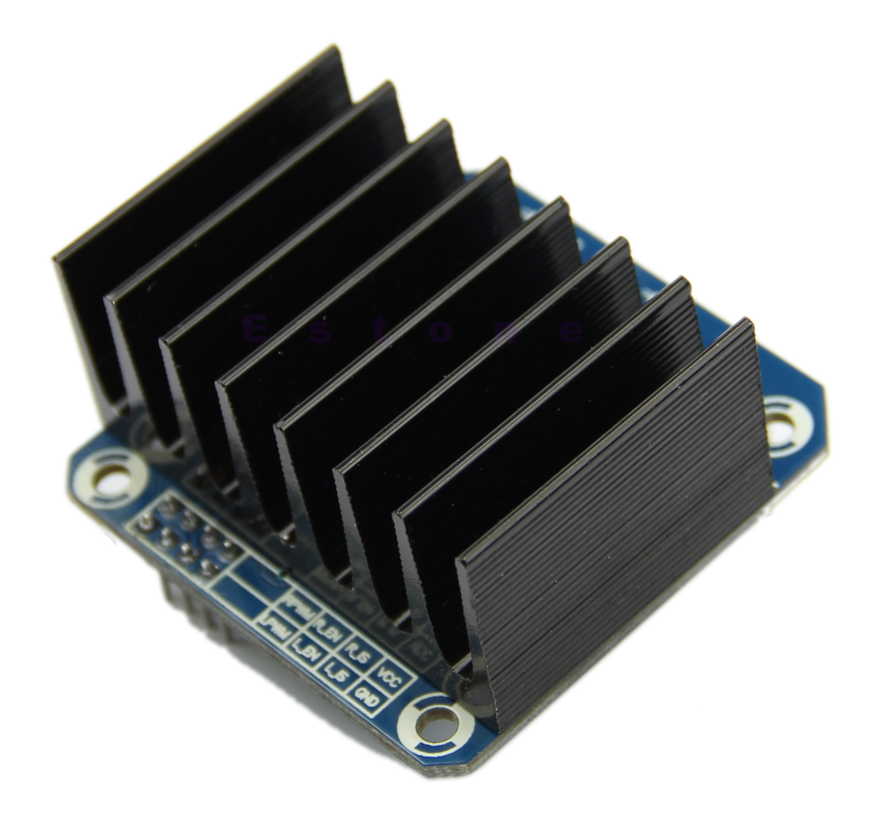 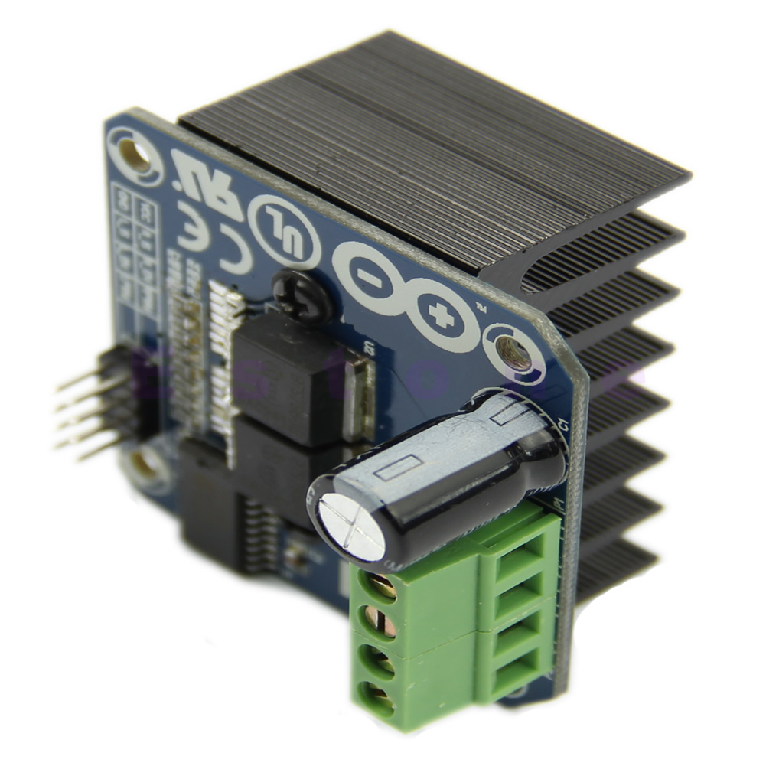 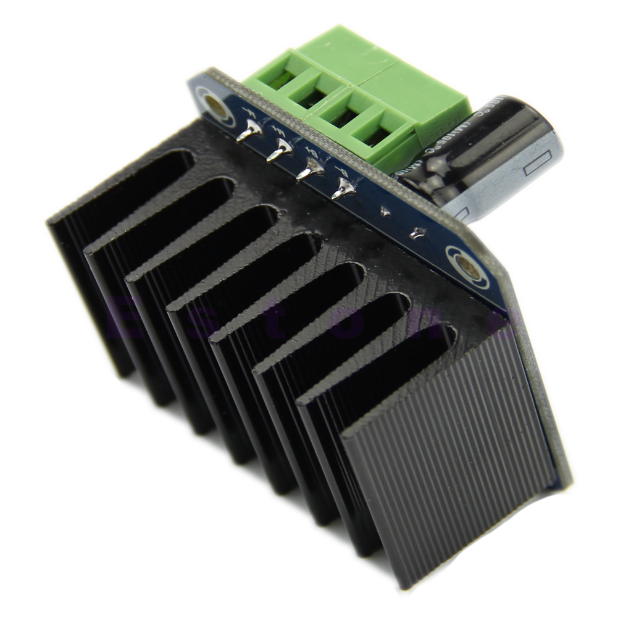



**Description:**

* **100% brand new and high quality**
* Quantity: 1pc
* Weight: 66 g
* Input voltage : 6V-27V
* Maximum Current : 43A
* Input level : 3.3V-5V
* Control mode : PWM or level
* Duty cycle: 0 to 100%
* Current conditioning output: yes
* Size:50mmx40mm/1.97"X1.58"(inch) (approx)
* **Features:**
* This driver uses Infineon chips BTS7960 composed of high-power drive full H-bridge driver module with thermal over-current protection. Double BTS7960 H-bridge driver circuit, with a strong drive and braking, effectively isolating the microcontroller and motor driver! High-current 43A
* **Specification:**
* *Double BTS7960 large current (43 A) H bridge driver;
* *5V isolate with MCU, and effectively protect MCU;
* *5V power indicator on board;
* *Voltage indication of motor driver output end;
* *Can solder heat sink;
* *Just need four lines from MCU to driver module (GND. 5V. PWM1. PWM2);
* *Isolation chip 5 V power supply (can share with MCU 5 V);
* *Able to reverse the motor forward, two PWM input frequency up to 25kHZ;
* *Two heat flow passing through an error signal output;
* *Isolated chip 5V power supply (can be shared with the MCU 5V), can also use the on-board 5V supply;
* *The supply voltage: 5.5V to 27V
* 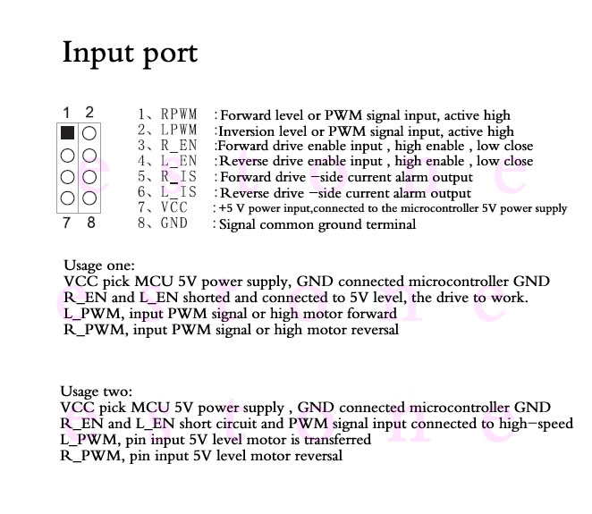

* If you need, please click this button below.

**Download**

* **Note: Due to the difference between different monitors, the picture may not reflect the actual color of the item. Thank you!**

I found a great tutorial on using this drive.

<http://www.hessmer.org/blog/2013/12/28/ibt-2-h-bridge-with-arduino/>

Here is his picture of how to hook it up.

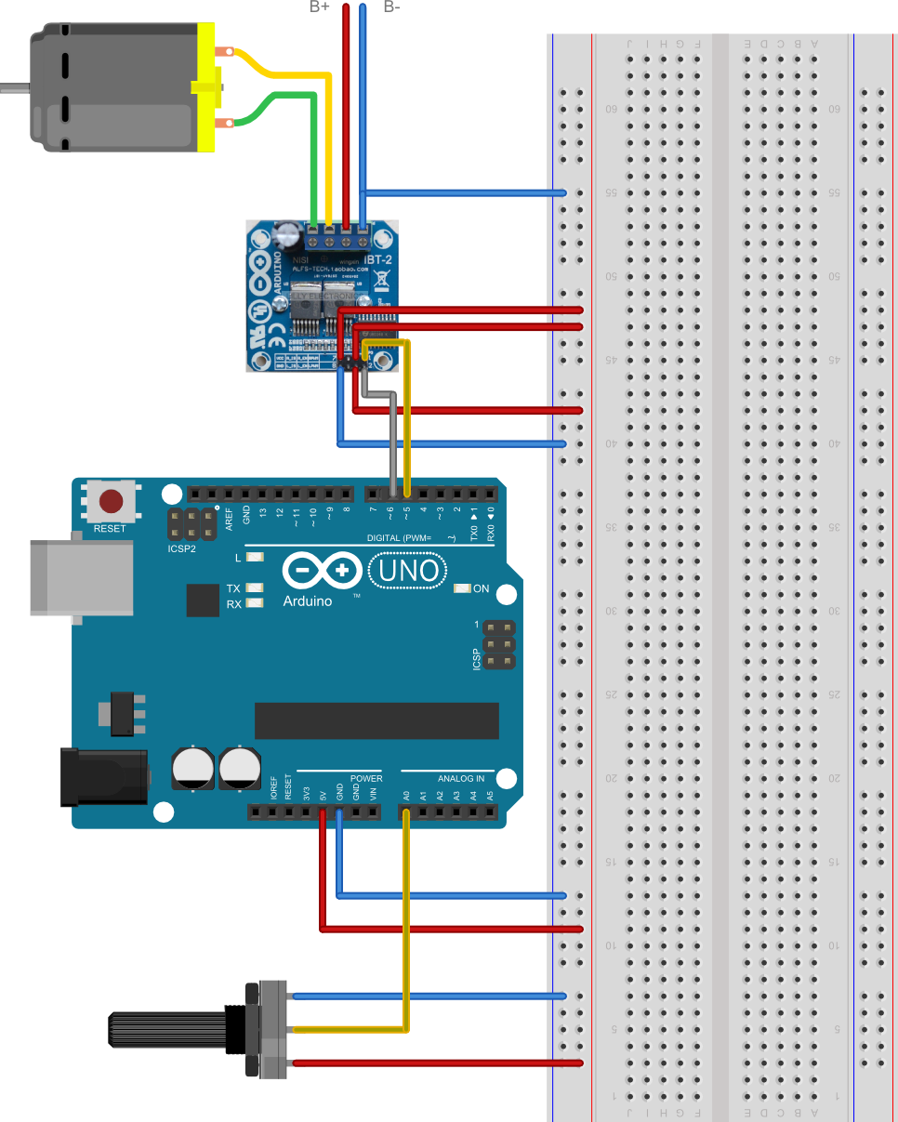

I put his code on my codebender.cc account for easy access.

<https://codebender.cc/sketch:217088>